Q. Write a program in python to demonstrate Simpson’s 3/8th rule.

Aim: To write a program in python to demonstrate Simpsons’s 3/8th rule.

Program:
def f(x):
return x**2 + 1

a = 0
b = 1
n = 6
h = (b - a) / n
sum3 = 0
sum2 = 0
print("------------------------------------------------------------")
print(" SIMPSON'S 3/8 RULE")
print("------------------------------------------------------------")
print(" i\t x\t\t f(x)")
print("------------------------------------------------------------")
for i in range(1, n):
x = a + i * h
fx = f(x)
print(f" {i:<2}\t {x:<10.6f}\t {fx:<10.6f}")
if i % 3 == 0:
sum2 += fx
else:
sum3 += fx
I = (3 * h / 8) * (f(a) + f(b) + 3 * sum3 + 2 * sum2)
print("------------------------------------------------------------")
print(f" Approximate value of integral = {I:.6f}")
print(f" Rounded to 4 decimal places : {round(I,4)}")
print("------------------------------------------------------------")

Output :
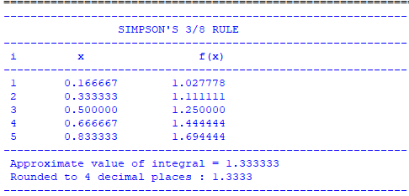

Conclusion: The above program has been executed successfully.

